1. Read and match. Przeczytaj i połącz.

|  |  |  |  |  |
| --- | --- | --- | --- | --- |
| Sum Test 1 | hair | page 18g | Sum Test 4 | eyes |
| Sum Test 2 | nose | Sum Test 5 | head |
| Sum Test 3 | ears | Sum Test 6 | mouth |

2. Read and colour. Przeczytaj i pokoloruj.

|  |  |  |
| --- | --- | --- |
| Sum Test 1 | orange hands |  |
| Sum Test 2 | blue ears |  |
| Sum Test 3 | yellow feet | Sum Test 1 |
| Sum Test 4 | red nose |  |
| Sum Test 5 | green body |  |
| Sum Test 6 | purple eyes |  |

3. Count and write. Policz i zapisz cyfrą.

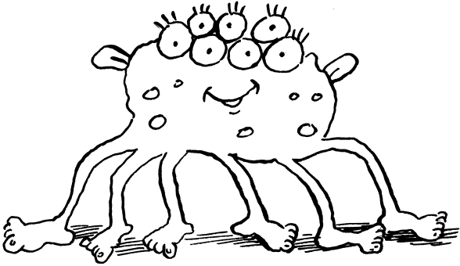

|  |  |
| --- | --- |
| Test 4A_aTest 4A_aHow many legs? – Ile nóg?  Numbering boxTest 4A_a | How many hands? – Ile dłoni?  Numbering box |

4. Trace and number. Napisz po śladzie i ponumeruj.

|  |  |  |
| --- | --- | --- |
| butter_dotted | Numbering box | sandwichesSum Test 1 |
| water_dotted | Numbering box | juiceSum Test 2 |
| sandwiches_dotted | Numbering box | honeySum Test 3 |
| oranges_dotted | Numbering box | orangesSum Test 4 |
| juice_dotted | Numbering box | waterbutterSum Test 5 |
| honey_dotted | Numbering box | Sum Test 6 |

5. Look, read and tick Tick (18pt) or cross Cross (18pt). Popatrz, przeczytaj i postaw znaczek Tick (14pt) lub Cross (14pt).

|  |  |  |  |  |
| --- | --- | --- | --- | --- |
| page 37sandwiches |  | Sum Test 1 | I like sandwiches. | Numbering box |
| juice |  | Sum Test 2 | I like orange juice. | Numbering box |
| butterham |  | Sum Test 3 | I like butter. | Numbering box |
|  |  | Sum Test 4 | I don’t like ham. | Numbering box |
| pizza |  | Sum Test 5 | I don’t like pizza. | Numbering box |
| jam |  | Sum Test 6 | I don’t like jam. | Numbering box |