A Look and match. Popatrz i połącz.

|  |  |  |  |  |
| --- | --- | --- | --- | --- |
| p1 bookcasep1 chairp1 tablep1 deskp1 doorp1 box | | | | |
| SSPKP2_10b |  | SSPKP2_10cSSPKP2_10dSSPKP2_10eSSPKP2_10f |  |  |

B Where’s the pencil? Gdzie jest ołówek?

|  |  |  |  |
| --- | --- | --- | --- |
| SSPKP2_10g | SSPKP2_10h | SSPKP2_10i | SSPKP2_10j |
| on the | on the | on the | on the |
| SSPKP2_10p | SSPKP2_10p | SSPKP2_10p | SSPKP2_10p |

C Match and colour. Połącz i pokoloruj.

|  |  |  |  |  |
| --- | --- | --- | --- | --- |
| four green books  six red rulers  seven blue pencils  nine yellow pens | SSPKP2_10k | SSPKP2_10l | SSPKP2_10m | SSPKP2_10n |

SSPKP2_10pD Read and answer. Przeczytaj i odpowiedz.

|  |  |  |
| --- | --- | --- |
| 14 | How old are you?  SSPKP2_10p |  |
| 15 | SSPKP2_10oWhat’s this? |  |

E Read and number. Przeczytaj i ponumeruj.

1. a ruler 2. a book 3. a pencil-case 4. a pen

|  |  |  |  |
| --- | --- | --- | --- |
| p14a | p14b | p14c |  |
| p14d | p14e |  |

F Read and complete the questions. Przeczytaj i uzupełnij pytania.

|  |  |  |  |
| --- | --- | --- | --- |
| p14f | | | |
| Lozenge 20 | Where’s the | p14k | It’s on the table. |
| Lozenge 21 | Where’s the | p14k | It’s on the floor. |
| Lozenge 22 | Where’s the | p14k | It’s on the chair. |
| Lozenge 23 | Where’s the | p14k | It’s on the bookcase. |
| Lozenge 24 | Where’s the | p14k | It’s on the desk. |

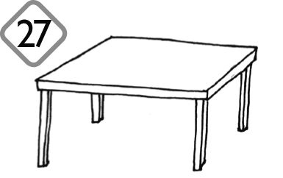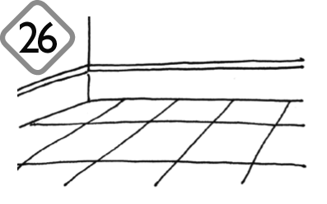G Read and draw. Przeczytaj i narysuj.

|  |  |
| --- | --- |
| Lozenge 25 | The book is on  p14lthe bookcase. |
| Lozenge 26 | The pen is  p14oon the floor. |
| Lozenge 27 | The pencil case  is on the table. |
| Lozenge 28 | The ruler is on the desk. |
| Lozenge 29 | p14qp14pThe pencil is on the chair. |
| Lozenge 30 | The rubber is on the floor. |