A Read and write. Przeczytaj i napisz. cooker bath sofa fridge
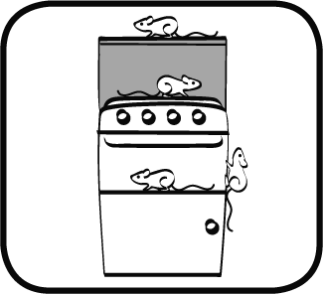
There’s a mouse on the __________________.
There are two mice in the _________________.
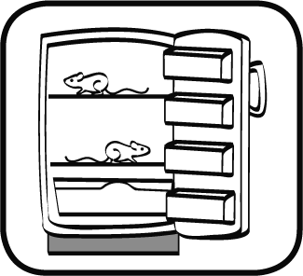
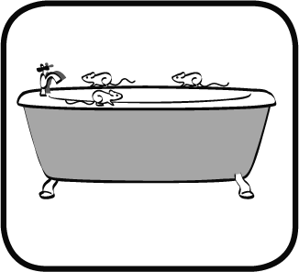
There are three mice on the _______________.
There are four mice on the ________________.
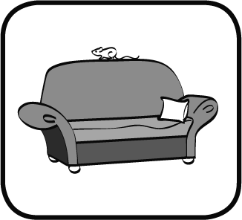
B Read and write. Przeczytaj i napisz. in on under behind
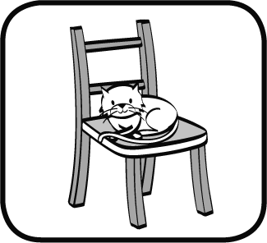
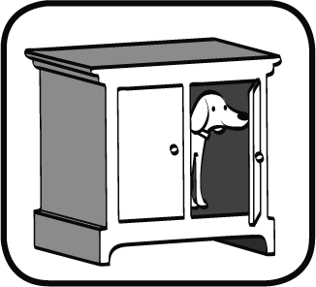
There’s a dog _________ the cupboard.
There’s a rabbit _________ the bed.
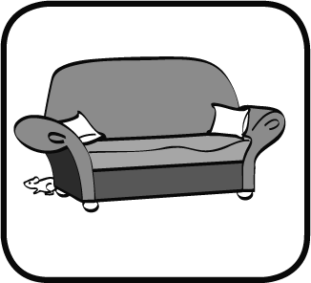
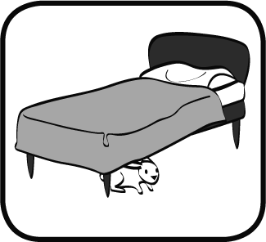
There’s a cat _________ the chair.
There’s a mouse _________ the sofa

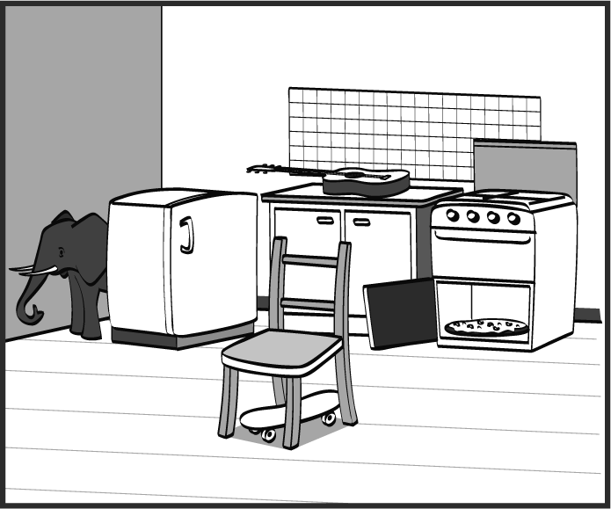
C Look and write. Popatrz i napisz.
Where’s the skateboard? ________________
Where’s the pizza? _____________________
Where’s the guitar? ____________________
Where’s the elephant? __________________

D Read and answer. Przeczytaj i odpowiedz.
Is there a computer in your bedroom? ______________________
Is there a cupboard in your dining room? ____________________
Where’s the fridge in your house? __________________________

E Write true T (true) or F (false).
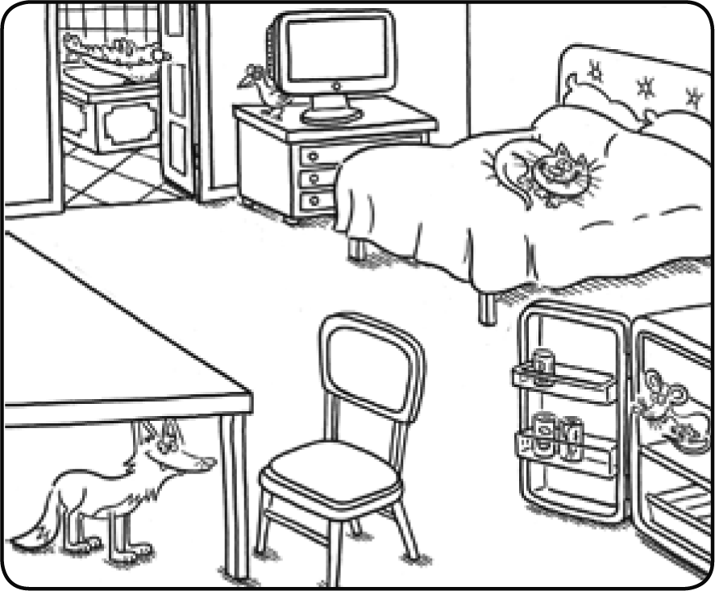
Posłuchaj i napisz, czy zdania są prawdziwe (T), czy fałszywe (F).
The cat is under the bed.
The fox is on the table.
The mouse is in the fridge.
The crocodile is under the bath.
The bird is behind the TV.

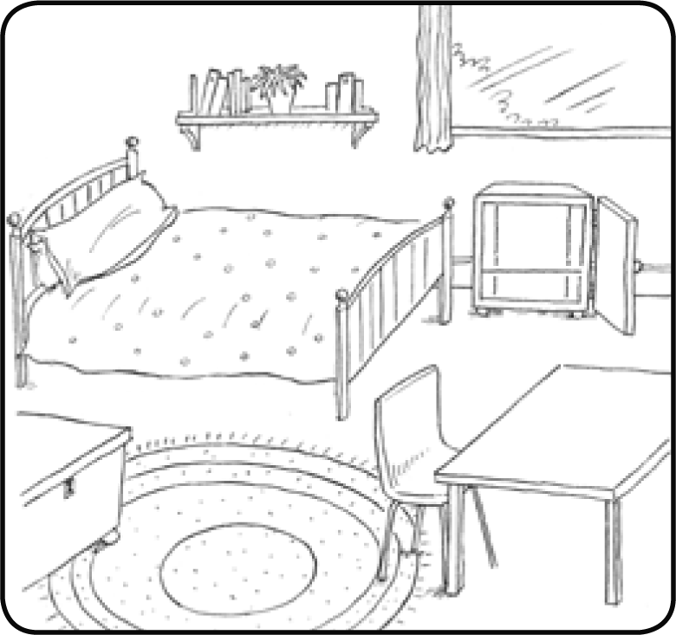
F Read and draw. Przeczytaj i narysuj.
There’s a camera on the chair.
There’s a cat under the bed.
There’s a jacket on the chair.
There’s a computer on the table.
There’s a cat in the cupboard.
There’s a frog behind the bed.

G Look and write the questions and answers.
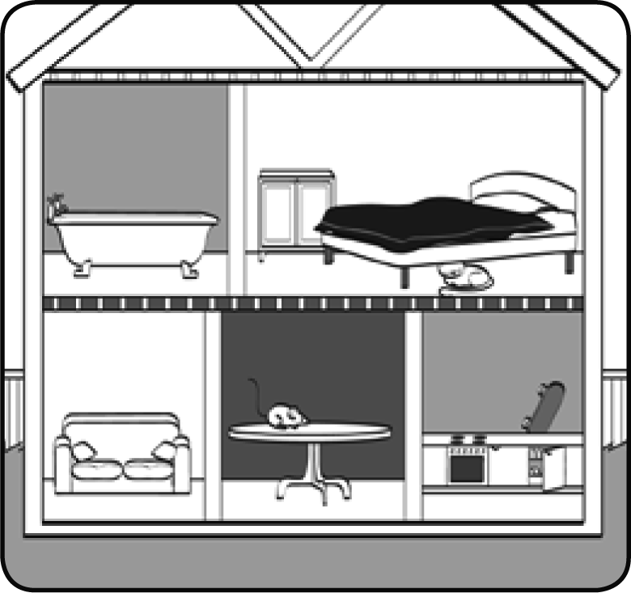
Popatrz i napisz pytania oraz odpowiedzi.
Where’s the cat?
It’s ___________ the bed.
_____________ the skateboard?
_____________ the fridge.
_____________ the mouse?
_____________ the table.
______________ the cupboard?
______________ the bed.

