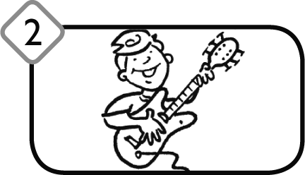
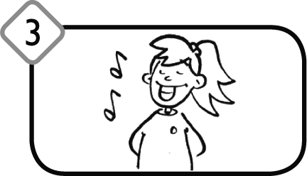
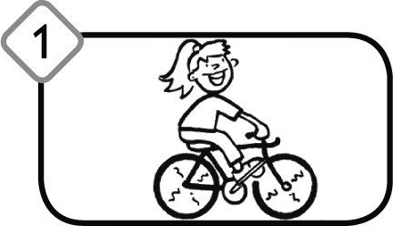
1. What’s he doing? What’s she doing? Match. Co on robi? Co ona robi? Połącz.

playing the guitar
eating
playing tennis
singing
riding a bike
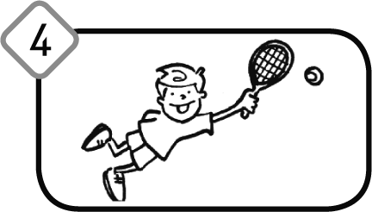 |  | 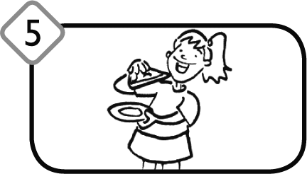

2. What’s he doing? What’s she doing? Match. Co on robi? Co ona robi? Połącz.

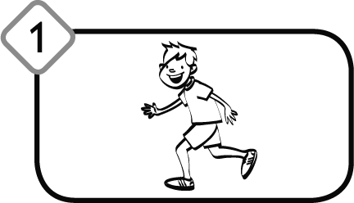 | 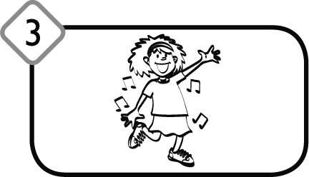  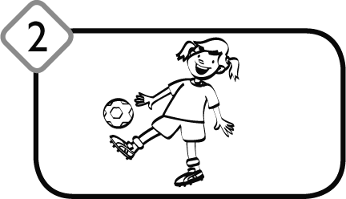 |  |  | playing football  eating  swimming  running  dancing
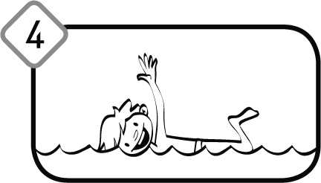 |  | 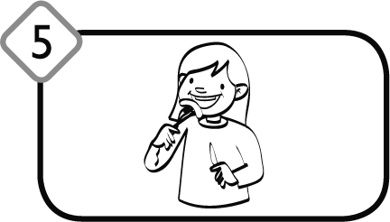

3. Look and write. Popatrz i napisz. | swimming eating  lying on the bed drinking
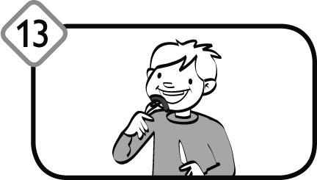
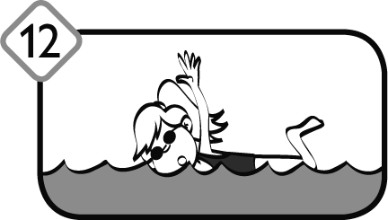
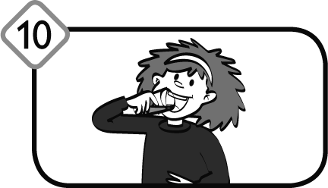
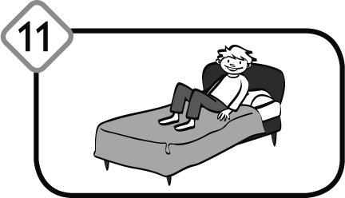
She’s  ____________. | He’s  ______________. | ____________  ____________. | ____________  ____________.

4. Look and write. Popatrz i napisz.
walking singing
drinking running

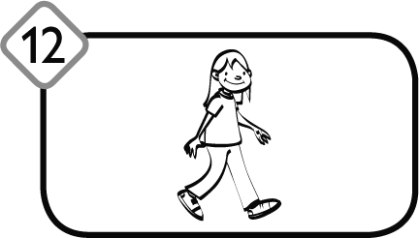
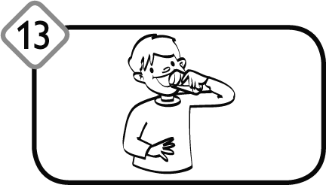
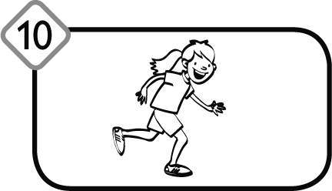
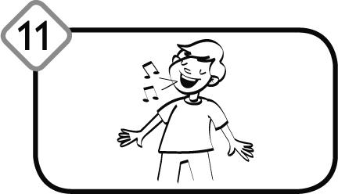
She’s  ____________. | He’s  _____________. | ____________  ____________. | ____________  ____________.

5. Look and write. What’s the weather like? Popatrz i napisz. Jaka jest pogoda?

rainy sunny windy cloudy
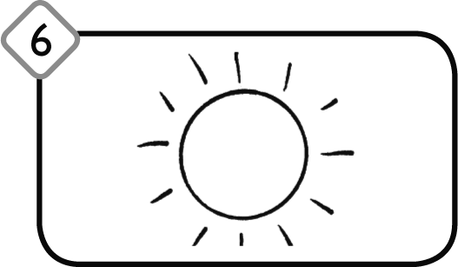 | 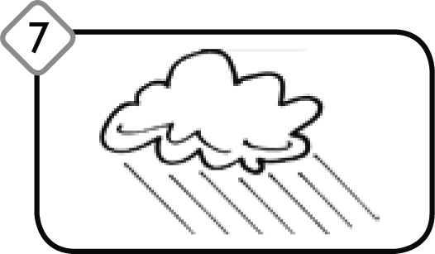  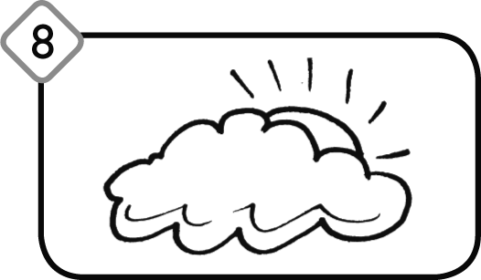 |  | 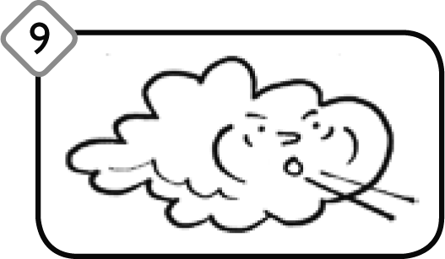
It’s _________. | It’s _________. | It’s _________. | It’s _________.

6. Read and match. Przeczytaj i dopasuj.

What’s the weather like today? It’s windy.
What’s the weather like today? It’s sunny.
What’s the weather like today? It’s cloudy.
What’s the weather like today? It’s rainy.

7. Look and write. Popatrz i napisz.
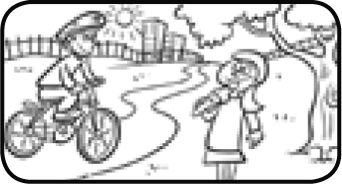
What’s the weather like today? It’s _____________.
What’s he doing? _He’s_ riding a bike.
What’s she doing? She’s__________________.

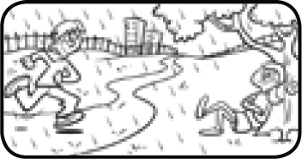
What’s the weather like today? It’s _____________.
What’s he doing? _______ running.
What’s she doing?_______ sitting.

